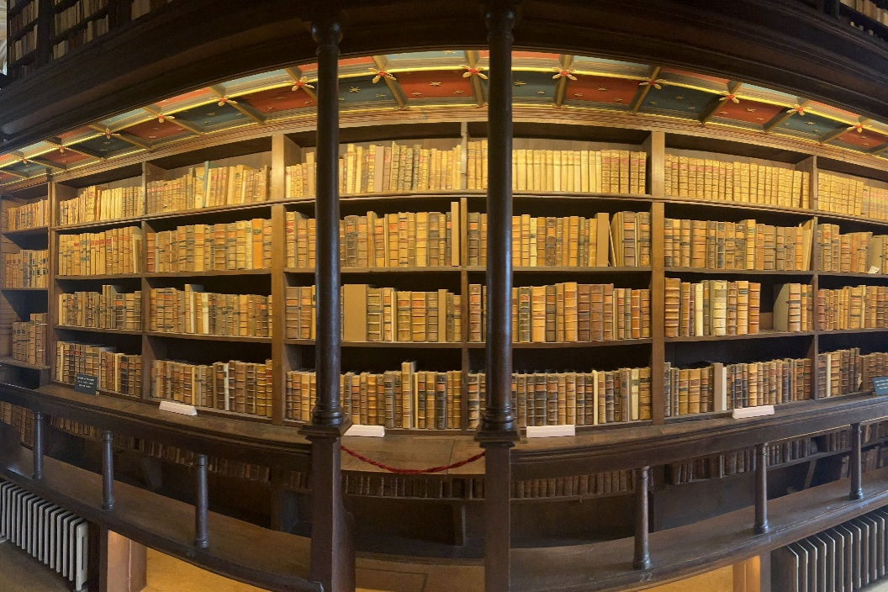

The History of the

written

Word of God

Part III – The Canon of the Old Testament

Ronald J. Frasco

I. Introduction
II. Original Languages
A. Old Testament
B. New Testament

III. Canon: The Process of the Human recognition of Scripture

A. Old Testament Canon
1. The term 'canon'
'The word ‘canon,’ borrowed by the Greeks from the Semites who themselves had borrowed it from the Sumerians, originally meant "reed." Because reeds were often used as measuring sticks, the words has come to have a variety of meanings related to measurement, including, "rule," "standard," "law," "boundary," "index."' LaSor, Hubbard, Bush, Old Testament Survey (OTS), p.17

'As applied to literature, canon has come to mean those writings which conform to the rule or standard of divine inspiration and authority.' Archer, A Survey of Old Testament Introduction, p.68

‘… the rule or standard by which a writing was judged to be inspired or authoritative.’ God to Us, pp.62-63

Thus, it was so used by early church father Athanasius (A.D. 350) to refer to books that 'measured-up' to God's standard.

2. Revelation and Canon
The church did not grant or bestow authority on the Books of Scripture. Rather, the church merely recognized the writings for what they already were – Divinely given, authoritative Revelation – the canon of Scripture.

'The only true test of canonicity … is the testimony of God the Holy Spirit to the authority of His own Word. This testimony found a response of recognition, faith, and submission in the hearts of God's people who walked in covenant fellowship with Him.' Archer, p.78

'The canonical books of the Old Testament were divinely revealed, and their authors were holy men who spoke as they were borne of the Holy Ghost. In His good providence God brought it about that His people should recognize and receive His Word … we may … follow our Lord, who placed the imprimatur of His infallible authority upon the books of the Old Testament.' E.J. Young, The Canon of the Old Testament, p.168, in C.F.H. Henry, Revelation and the Bible

One historian (G&N chart p.221) presents a helpful chart showing the different perspectives on the matter …

The Incorrect View | The Correct View
The Church is …  Determiner of Canon  Mother of Canon  Magistrate of Canon  Regulator of Canon  Judge of Canon  Master of Canon | The Church is …  Discoverer of Canon  Child of Canon  Minister of Canon  Recognizer of Canon  Witness of Canon  Servant of Canon

3. ‘Inscripturation’ and Canon
God communicated to man, by means of the Holy Spirit speaking through human authors (2Pe 1:20-21). This we refer to as inspiration. The Bible, though written by men, was conveyed through the Holy Spirit. . These authors thus composed and compiled God's written Word (Heb. 1:1). This we refer to as inscripturation. For God's purposes and man's edification, the Holy Spirit preserved these writings to the present thereby providing us with a trustworthy record of God's revelation to humanity.

‘… for the sake of future generations and in the light of his ongoing redemptive purpose, God did will that some of His revelation be written down so that His redemptive acts in former generations might serve as examples to those who came later. The result of this inscripturation is the Bible.’ OTS, p.12

4. Stages in the development of the Canon
LaSor, Hubbard and Bush offer a helpful approach in the consideration of the process which produced the Canon of Scripture: 'authoritative utterances, documents, collections of writings, and a fixed canon.' (OTS, p.18)

'Authoritative Utterances … began when they received the law through Moses at Mt. Sinai.' ibid, p.18

'Authoritative Documents … In Deut. 31:24-26, Moses ‘finished writing the words of this law in a book’ and commanded the Levites to ‘put it by the side of the ark of the covenant … that it may be there for a witness against you.' ibid, p.18

'Authoritative Collections of Writings … The traditional threefold division of the Hebrew scriptures into Law, Prophets, and Writings probably indicates stages in the formation of the canon as well as differences in the subject matter.' ibid, p.19

'Fixed Canon … Evidence for the threefold catalog of sacred writings is found prior to 150 B.C.' ibid, p.21

5. The Canon of the Old Testament
The first to list our present 39 Old Testament books was the Alexandrian list in approximately A.D. 70. This list included the Apocrypha but did not regard it as Scripture. The Apocrypha were writings from both Old and New Testament times which were neither ever seriously regarded as Scripture nor ultimately accepted as such.

'This collection was gradually formed by the Jews for their own religious purposes, but they did not of course call it the Old Testament. They called it – The Scriptures, or – The Law and the Prophets, or simply – The Law.' Goodspeed, Story of the Bible, p.161

Note the reverential attitude regarding canonical books; they were considered holy …

'… in the later Talmudic tradition, the canonical, or sacred, books were called those that 'defile the hands' of the users, because the books were considered holy … contact with the Scriptures really sanctified the hands, but it was called uncleanness because the hands had to be washed before touching other things, in accordance with Leviticus 6:27f; 16:23f, 26, 28.' Geisler & Nix, General Introduction to the Bible (GIB), p.205

We must always maintain a distinction in our mind between the revelation of God's Word, that which was recognized to be 'canonical,' and the canonization or recognition itself. God's revelation, the 'canon' of the Old Testament, was complete long before it was recognized as such.

'The OT Canon was probably completed about 400 B.C. … originally canonized into the twofold division of the Law (five books) and the Prophets (seventeen books) … the final form of the Hebrew canon eventually became threefold: the Law, the Prophets, and the Writings [Some of the books of the Prophets did not fit neatly into the continual sequence of the history of the prophets – Psalms, Proverbs, etc].' GIB, p.243, 255

In the study and consideration of the canon of Scripture, some key terms should be understood.
Antilegomena – '… originally accepted into the canon … subsequently disputed.' GIB, p.258

Song of Solomon – too sensual
‘The criticism of the Song of Solomon was based on the passages in it which speak of physical attractiveness in bold and enthusiastic imagery …’ Archer, p.71

In other words, they deemed it too racy.

However, it is entirely possible 'that God has placed this Song in the canon in order to teach us the purity and the sanctity of that estate of marriage which He Himself has established.' E.J. Young, An Introduction to the Old Testament, p.355

Ecclesiastes – too skeptical
'The criticism of Ecclesiastes was based upon its alleged pessimism …' Archer, p.71

However, Solomon comes to a great and God-honoring conclusion!

Ecclesiastes 12:13
The conclusion, when all has been heard, is: fear God and keep His commandments, because this applies to every person.

Esther – '… because of the conspicuous absence of the
name of God …' GIB, p.260

Ezekiel – '… because of its apparent anti-Mosaical
teachings.' GIB, p.261

'… the problem it presented consisted in the disagreements of detail between the latter-day temple and ritual of the last ten chapters and those of the Mosaic tabernacle and Solomonic temple.' Archer, p.72

Proverbs – deemed to be 'illogical.' GIB, p.261

Proverbs 26:4–5
:4 Do not answer a fool according to his folly, Or you will also be like him.
:5 Answer a fool as his folly deserves, That he not be wise in his own eyes.

Pseudepigrapha – books rejected by all as 'spurious and unauthentic' GIB, p.262-263

Dozens of such writings – 18 prominent

Apocrypha – '… books mistakenly viewed as part of the OT canon.' GIB, p.264

The word 'apocrypha' originally meant 'something hard to understand,' or 'hidden.'

The Apocryphal debate did not originate in the 16th century – i.e. during the Reformation. Rather, it came to light most prominently during this period due to a convergence of canon traditions – one which accepted the Apocrypha, one which did not.

Homologoumena

‘The biblical books which were accepted by all were called ‘homologoumena’ (lit., to speak as one).… never seriously challenged by any of the great rabbis within the Jewish community. Once these books were accepted by God’s people …, they continued to be recognized as divinely authoritative by subsequent generations.’ God to Us, p.86

'… books which once they were accepted into the canon were not subsequently questioned or disputed.' GIB, p.257

'Homologoumena comprise 34 of the 39 books in the English versions of the Protestant OT.' G&N, p.258 [Emphasis mine.]

