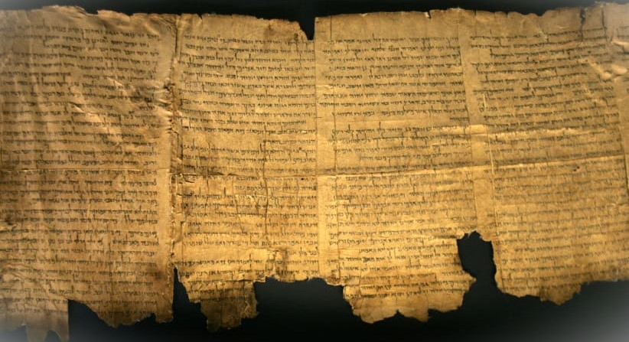

The History of the

written

Word of God

III. A. The Canon of the New Testament

Ronald J. Frasco

I. Introduction
II. Original Languages
A. Old Testament
B. New Testament

III. Canon: The Process of the Human recognition of Scripture

- Old Testament Canon
- New Testament Canon
1. The Canon of the New Testament
The process of recognizing the New Testament was much slower. Its history may be traced through Citations, Lists, Translations and Councils.

a. Gradual Revelation and Writing – A.D. 45-95
"Apart from the Old Testament, Christianity had no authoritative writings for the first 15 years of its existence. Proclamation during this period was solely by word-of-mouth based on the Old Testament and the tradition of eyewitness reports which were primarily oral. Doctrinal and practical issues among early Christians created the need for epistles first (beginning with James in the late forties). These were written by early apostles and prophets on the basis of direct revelations given them by God. Epistles continued to appear … About ten years after the first epistle was written, as eyewitnesses of Jesus' earthly life and resurrection became more scarce and Christianity spread to the extent that there were not enough to tell the story of His life orally, the Gospels began to appear." Robert Thomas, The Canon of the New Testament

b. Gradual collection and recognition
i. Factors preventing immediate collection
Gradual revelation – the books of the NT were not all revealed and written at the same time.

Isolated circulation – the written revelation was not broadly distributed; in many cases, the books were written to particular churches, or even particular individuals.

Limited communication – the written revelation was prevented from a rapid dissemination by a very rudimentary communication system.

Gradual recognition – As a result of the above-mentioned difficulties, the gathering and canonization of the New Testament was a slow process. This process was made even more difficult by the broad and rapid spread of the Gospel, and thus the varied destinations of many of the writings.

ii. Factors leading to the official collection of
Christian Scripture
- The existence of the Old Testament
- The authoritative nature of the NT books
- The use of these books in worship services
- The use in doctrinal controversy
- Marcion's canon – heretic who published his own list A.D. 140 – included only Luke, ten of Paul's letters (no pastorals), NO Old Testament!
"He had become convinced that the God of the Old Testament could not be identified with the loving heavenly Father whom Jesus proclaimed, and so he rejected the Old Testament. Something had of course to be put in its place for purposes of Christian worship and devotion, and Marcion proposed a Christian collection, consisting of the Gospel of Luke and ten letters of Paul." Goodspeed, Story of the Bible, p.139
- The persecution of the church, including the destruction of its sacred writings
- Constantine's Law – he followed Diocletian – A.D. 313 declared Christianity the official state religion – requested Eusebius to make 50 copies of the New Testament
- The materials on which these writings were written
"… the original copies of the New Testament books were made on papyrus, which was the ancient paper.… This substance was by no means durable.… use and exposure to the atmosphere caused its sure and speedy destruction.… Our possession of these truths would have been utterly lost had it not been for two source of preservation, namely, the numerous copies of these books … and, secondly, the abundance of Scripture quotation, in which the early disciples habitually indulged in their writings.… they took special delight in citing extensively from the Scriptures." Hall, History of Revision, pp.15, 29

iii. Factors in determining Canonicity

Was the writing …
- written or endorsed by a prophet or an apostle?
- attested to or confirmed by acts of God?
- Theologically accurate? Did it speak accurately about God and His plan of redemption?
- attended with the power of God?
- accepted by the Church, the people of God?

iv. Periodic stages in New Testament Canon
"As to what should be included in this library of preferred and authoritative Christian writings, there was agreement among the churches in regard to general outlines, but no little diversity of views as to details. All accepted the Four Gospels … and the thirteen letters of Paul … The Acts of the Apostles and three or four epistles, one of Peter … one or two of John … Jude, were also generally accepted.… Eastern churches … holding Hebrews to be the work of Paul, put it into their New Testament, but it was nearly two hundred years before Rome and the western churches admitted this. The west, on the other hand, accepted the Revelation of John as early as the middle of the second century, but the East never [?] fully recognized its right to a place in the New Testament. The lesser epistles of John, Peter, and James were variously treated, some accepting them and others refusing to do so." Goodspeed, Story of the Bible, pp. 141
Period One – A.D. 70-170 – sluggish circulation and collection
Limited communication system.
Quoted or alluded to by many Christian writers.

Period Two – A.D. 170-303 – separating true from false
Muratorian Canon – c. A.D. 170 in Milan, IT
Includes 22 of our present 27; missing are: Hebrews, James, 1&2 Peter, 2 and 3 John.

Tertullian – A.D. 150-222 in Carthage
Influential lawyer – cites as Scripture from 22 of 27 NT books – not mentioned are: Hebrews, James, 2Peter, and 2 and 3 John.

Clement of Alexandria – A.D. 155-215
Includes 24 of 27 NT books – omits: James, 2Peter, 3John; but includes many books not in our canon.

Hippolytus – A.D. 170-236
Cites as authoritative all but Jude, Philemon, and 2 and 3 John.

Origen – A.D. 186-254
Brilliant Christian Scholar – supported nearly every one of our 27 books and rejected most others.

Indicating books challenged in the canon process

 | Heb | Jas | 1Pe | 2Pe | 2Jn | 3Jn | Jude | Phm
Muratorian
Tertullian
Clement
Hippolytus
Origen
Eusebius

Period Three – A.D. 303-397 – affirming the canon
Eusebius – A.D. 270-340
Excluded James, 2 Peter, 2&3 John and Jude.

Council of Laodicea – A.D. 363
Discussion but no official list.

Athanasius – A.D. 365 [367? Goodspeed]
He was the first to list our 27 NT books as Scripture and exclude all other Christian literature.
"But long after that time there continued to be some disagreement in different places … as to just what books were entitled to be considered the inspired and authoritative Christian writings." Goodspeed, Story, pp.142-143

Council of Hippo – A.D. 393
Discussions and list but results were lost.

Council of Carthage I – A.D. 397
Present canon received!

Council of Carthage II – A.D. 419
Present canon reaffirmed.

- A.D. 398 to present – attacking the canon!
Throughout history, down to our own day, at Universities, liberal churches, and in the hearts of doubters everywhere, the canon of Scripture remains under a constant, relentless attack!

“Scripture is the foundation of the Church; the Church is the guardian of Scripture. When the church is in strong health, the light of Scripture shines bright; when the Church is sick, Scripture is corroded by neglect … the way in which Scripture is being treated is in exact correspondence with the condition of the Church.” Albert Bengel, 1742

2.. Is the 'canon' closed?

'… the canon is closed theologically …
God has inspired only so many books and they were all completed by the end of the apostolic period … there is no new revelation for the church.

and historically,
It seems highly unlikely that God would inspire a book in the first century that is necessary for faith and practice and then allow it to be lost for nearly two thousand years.

and is open only hypothetically …
It is theoretically possible that some book written by an accredited apostle or prophet from the first century will yet be found … [But] it is providentially improbable that God would have inspired but left unpreserved for two millennia what is necessary for the instruction of believers of all generations.' G&N, pp.217-218

What things might have prompted the collection of what would become “New Testament” writings?

Before the collection of what would become “New Testament” writings, how did Christians learn of Christ?

How were they taught, corrected, and instructed?

What role would false teachers / false teaching have had in securing writings that would become the “New Testament”?

What inhibited the collection and establishment of a New Testament Canon?

How would the materials on which books were written in the 1st century have hastened the collection of writings that would become the “New Testament?

What might be some of the factors for determining whether or not a writing was ‘canonical’, that is, sacred and to be included in the New Testament collection of books?

What factors prompted the gathering of sacred writings?

How long (how many years) did it take to gather the writings that would eventually become the New Testament?

Were all such writings automatically received?

What was the first time that our 27 books of the New Testament were listed?

