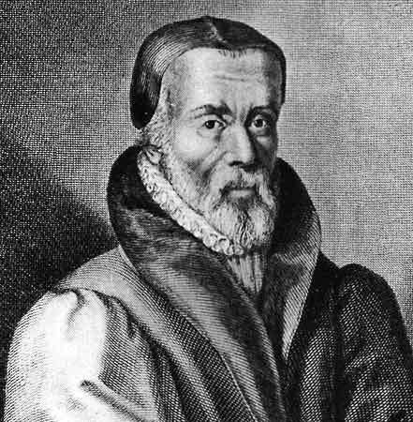

‘Master’ Tyndale

The History of the

written

Word of God

V.B. The English Bible – 16th C Branch

Ronald J. Frasco

B. 16th century Branch

William Tyndale – 1526

God raised up another man to continue the reformation of the church – William Tyndale. He was uniquely gifted by God for a specific task – he was, as one historian notes,

a man of sufficient scholarship to work from Hebrew and Greek, with a genius to fashion a fitting English idiom and faith and courage to persist whatever it cost him.

His disdain for the falseness of the Roman Catholic church and his love for God's Word are plainly evident from a well-known exchange. While conversing with a theologian, he was shocked to hear the man place the pope above Scripture saying, "We were better to be without God's laws than the Pope's." Fox recounts Tyndale's famous response.

Master Tyndale, hearing this, full of godly zeal, and not bearing this blasphemous saying, replied, "I defy the pope, and all his laws;" and added, "and if God spare me I will one day make the boy that drives the plough in England to know more of Scripture than the pope himself!"

It was Tyndale's deepest desire to reform the church and the surest way to achieve that would be, as he clearly saw, to place the Scriptures in the hands of the people! In the words of John Fox, Tyndale saw no higher calling for himself than:

If the Scripture were turned into the vulgar [common] speech, that the poor people might read and see the simple plain Word of God. He perceived that it was not possible to establish the lay people in any truth, except the Scriptures were so plainly laid before their eyes in their mother tongue that they might see the meaning of the text. . . . Master Tyndale considered this only, or most chiefly to be the cause of all mischief in the Church, that the Scriptures of God were hidden from the people's eyes . . .

Thus, as any of God's saints, willing to be mightily used by Him – Tyndale responded as Isaiah, "Here am I. Send me!" Again, Fox details how Tyndale …

left his native land, never to see it again; and … in poverty and distress, and amid constant danger, the self-sacrificing exile worked at his translation.

One historian details Tyndale’s capabilities and his effort …

Tyndale was a good Greek scholar and produced an excellent translation, over ninety percent of which the King James Version retained …

In God's providence, the invention of the printing press by Gutenberg would greatly improve Tyndale's chances for getting the Scriptures to the people. He used the original Hebrew and Greek manuscripts from which to translate. So strong was the reaction to this by the Pope and his system against Tyndale and his work that his English New Testament had to be smuggled into England! Nevertheless, Tyndale's toil and sacrifice bore much fruit. Fox records …

The godly books of Tyndale, and especially the New Testament of his translation, after that they began to come into men's hands, and to spread abroad, wrought great and singular profit to the godly …

Dr. Robert Thomas recounts an amazing

The [Roman Catholic] church was at the point of charging Tyndale with heresy … when he undertook a translation of the New Testament, he had to leave England in Germany and France to do the work. Even there he found opposition but was finally able to complete the New Testament and have it printed … It became available in England in 1526. When the work arrived in England, the Bishop of London tried to seize all the copies and burn them in a public place. The destructive campaign was a failure, however. The money the Bishop used to buy up all the copies was used to print more copies of Tyndale’s English New Testament.
Tyndale's work started a landslide of truth upon the land that would prove to be irreversible to this day. Approximately 200 copies of Tyndale's manuscripts survive. But more importantly, the Reformation that the Scriptures initiated, which once seemed no more than the passing phase of a disgruntled few, would ultimately sweep through the land and change the church forever.

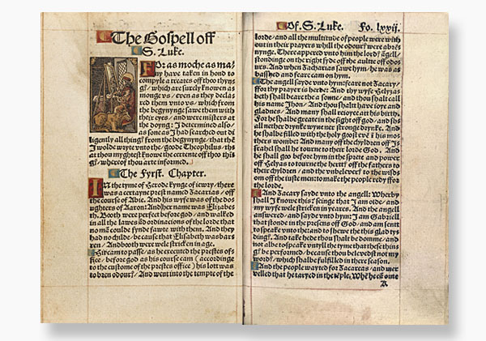

The reaction to Tyndale's work became venomous, labeled specifically as heretical. His reaction to this charge was strong. Writing to his friend, John Frith (who himself would become a martyr), he declared,

I call god to record against me the day we shall appear before our Lord Jesus, that I never altered one syllable of God's Word against my conscience, nor would to this day, if all that is in earth, whether it be honor, pleasure, or riches, might be given me.

Tyndale had taken his last stand against the Pope and would now pay the ultimate price in his service to Christ's Church. In Antwerp, Belgium, he was kidnapped and imprisoned. He was eventually convicted of heresy and sentenced to death. He was led forth to be burned on Friday, October 6th, 1536. Fox recounts his final hours,

At last, after much reasoning, when no reason would serve, although he deserved no death, he was condemned by virtue of the emperor's decree … Brought forth to the place of execution, he was tied to the stake, strangled by the hangman, and afterwards consumed by fire … crying at the stake with a fervent zeal, and a loud voice, "Lord, Open the King of England's eyes."

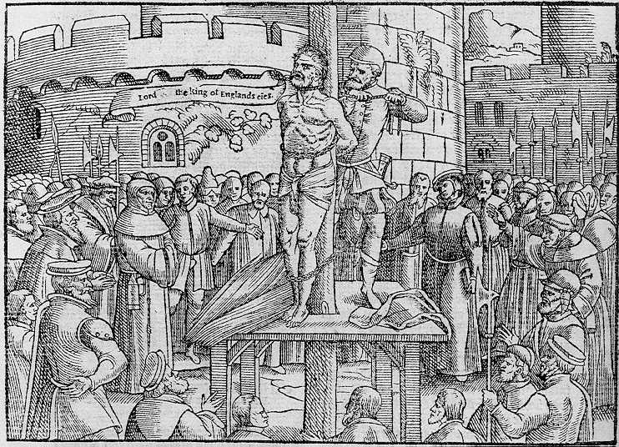

In God's providence, however, within a single year of Tyndale's martyrdom, there would be two significant versions of the Bible in print and available to the people – the Coverdale Bible and Matthew's Bible.

Coverdale Bible – 1535

Tyndale's assistant, Miles Coverdale, was deeply involved in the production of the Bible in English. He was involved an edition that bore his name but was also instrumental in the completion of both the Great Bible (1539) and the Geneva Bible (1560). His Coverdale Bible was essentially a revision of Tyndale's Bible, the first complete printed Bible in English. At least part of the reason for Coverdale's prominence in this translation was political. One scholar explains,

The undertaking itself, and the choice of Coverdale as the translator, were probably due to Cromwell. Tyndale's controversial treatises, and the polemical character of his prefaces and notes, had irritated the leading ecclesiastics and embittered the mind of the king himself against him. All that he had written was publicly condemned. There was no hope of obtaining the king's sanction for anything that bore his name.

Coverdale's prominence worked. Upon its completion, King Henry ordered Coverdale's bible placed in every church!

We get a clear sense of Coverdale's heart for this work in an appeal taken from the preface to his translation,

Go to now (most dear reader) and sit thee down at the Lord's feet and read his words, and, as Moses teacheth the Jews, take them into thine heart, and let thy talking and communication be of them when thou sittest in thine house, or goest by the way, when thou lyest down, and when thou riseth up. And above all things fashion thy life and conversation according to the doctrine of the holy ghost therein.

Matthew's Bible – 1537

John Rogers took up Tyndale’s cause of translating the Scriptures into English. In order to avoid the same treatment that his predecessor, Tyndale, had experienced, he took up the alias, Thomas Matthew. Fox details that,

Matthew' was a pen name of John Rogers who would eventually become the first of Queen Mary's martyrs. Queen Mary ("Bloody Mary") had seen to it that laws were passed giving the Roman Catholic Church authority to give over for burning all persons who refused to acknowledge the Pope.

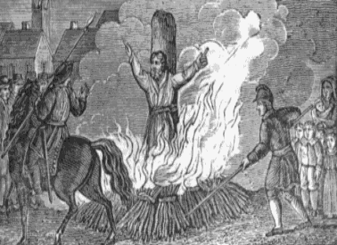

Rogers’ attempt to hide his identity eventually failed. After he revised Tyndale and Coverdale's Bible, he began to suffer the persecution common to the day. Fox recounts,

Rogers was brought by the sheriffs toward Smithfield, repeating the fifty-first Psalm by the way, [as he passed by his] wife and eleven children … This sorrowful sight of his own flesh and blood did not move him; but he constantly and cheerfully took his death with wonderful patience in defense of Christ's Gospel.… all the people greatly wondering at his constancy; and there … he was fastened to the stake and burned to ashes.

Taverner's Bible – 1539

Richard Taverner, a very capable Greek scholar, revised "Matthew's Bible." He did not possess any formal ecclesiastical title – he was a 'layman.' History records that he first got himself in hot water for doing what was considered unthinkable – he was caught reading Tyndale's New Testament. He would later see much greater trouble for printing his own translation of the Scriptures, which he titled, The Most Sacred Bible. He was jailed by King Henry VIII in the Tower of London.

Unfortunately for him, his timing in publishing his translation could not have been worse. Cromwell's Great Bible was also published in the same year. Thomas Cromwell decreed that the Great Bible would be placed (chained) to the pulpit in every church in all of England.

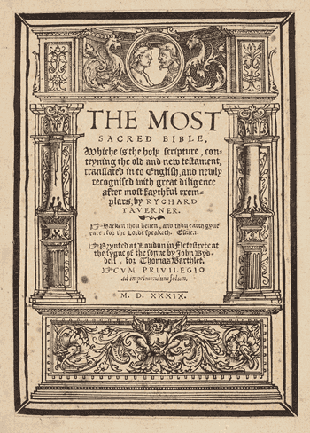
Great Bible – 1539

Called "Great" because of its immense size, this Bible was revised under a collaborative effort of both Thomas Cranmer and Miles Coverdale. Although Coverdale had successfully produced his own revision of Tyndale's work just four years earlier, the Great Bible was a revision of John Rogers' Matthew's Bible. Matthew's Bible was controversial and not well-received since it was so closely tied to Tyndale. In other words, the failure of the Matthew's Bible was not due to the capabilities of the translator …

Coverdale, though without the force and originality, or even the scholarship, of Tyndale, had some of the more valuable gifts of a translator, and was well qualified to make the best use of the labors of his predecessors. He had scholarship enough to choose and follow the best authorities, he had a happy gift of smooth and effective phraseology, and his whole heart was in his work.
The Great Bible was the first version to boldly present itself as 'the Byble apoynted [16th century spelling uncorrected] to the use of the churches.' One historian describes the process,

The first edition of the Great Bible appeared in April 1539, and an injunction was issued by Cromwell that a copy of it should be set up in every parish church. It was consequently the first (and only) English Bible formally authorized for public use, and contemporary evidence proves that it was welcomed and read with avidity.

Geneva Bible -- 1560

The Geneva Bible, also called the "The Puritan Bible," was a thorough revision of both Tyndale and Coverdale's versions. Coverdale and others had fled persecution in England and settled in Geneva, Switzerland. It was the first to use modern chapter and verse divisions and italics for supplied words, it was printed in Roman type and had decidedly Calvinistic notes in the margins. It was tremendously popular and underwent approximately 140 editions! The Geneva Bible would be used heavily by the translators of the King James fifty years later.

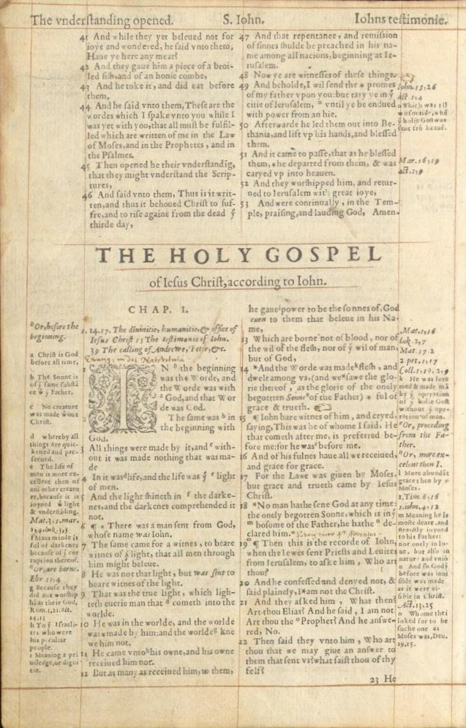
Bishop's Bible – 1568

The Bishop's Bible was a short-lived revision of the Great Bible, compiled in reaction to the Geneva Bible. This effort was championed and led by England's ecclesiastical authorities, hence the title – the 'Bishop's Bible.' While the Geneva Bible was immensely popular, its favor was not universal,

… there was one quarter in which the Geneva Bible could hardly be expected to find favor, namely, among the leaders of the Church of England. Elizabeth herself was not too well disposed towards the Puritans, and the bishops in general belonged to the less extreme party in the church. On the other hand, the superiority of the Genevan to the Great Bible could not be contested.

But, by all accounts, this effort to have the Bishop's Bible overtake the popularity of the Geneva Bible was a complete failure. Although it was officially sanctioned and ordered to be placed in all of the churches, it could not overtake the popularity of the Geneva Bible in the hearts and homes of the people.

The Bishops' Bible, in fact, superseded the Great Bible as the official version, and its predecessor ceased henceforth to be reprinted; but it never attained the popularity and influence of the Geneva Bible.

Though the Bishop's Bible was not well-received by the general public, it would remain the official Bible of the Church of England for the next fifty years.

… the Bishops' Bible continued in official use until its supersession by the version of 1611, of which it formed the immediate basis.

S.L. Greenslade, Cambridge History of the Bible, v.3, p.141
BOM, p.178; CMW, p.351
ibid, p.179
CMW, p.352
BOM, p.181
Robert Thomas, How to Choose a Bible Version, p.14
BOM, p.184
E.H. Plumptre, in William Smith's Dictionary of the Bible, pp.3429-30
CMW, p.420
CMW, pp.422-423
Frederic G. Kenyon, in James Hastings' Dictionary of the Bible
ibid
Kenyon
ibid
ibid

